**Subscription Based E-Commerce App**

# 1. Introduction

This design document outlines the structure, functionality, and design considerations for the Subscription based E commerce Application.The purpose of this document is to provide a comprehensive overview of the application's design, including its architecture, core features, user interface, and technical requirements. This will serve as a reference for the development team and CodeFury’s Team.

2. System Architecture

The system follows a layered architecture with separation of concerns. It consists of the following layers:

1. **Models**: Represents the core business entities.
2. **Service Layer**: Contains business logic and operations.
3. **DAO Layer**: Manages data access and persistence: CRUD Operations
4. **Exceptions:** Handling of Exceptions is done here.

**2.1 Model**

The Model includes the core business entities with their attributes and methods. These entities are:

* **Admin**
* **User**
* **Customer**
* **Order**
* **Products**

**2.2 Service Layer**

The service layer contains business logic and provides methods to interact with the domain objects. The services include:

* **AdminService**
* **UserService**
* **CustomerService**
* **OrderService**
* **ProductService**

**2.3 DAO Layer**

The DAO (Data Access Object) layer is responsible for CRUD operations on the database. This layer interacts with the database and provides methods to fetch or update data.

3. Data Flow Diagram (DFD)

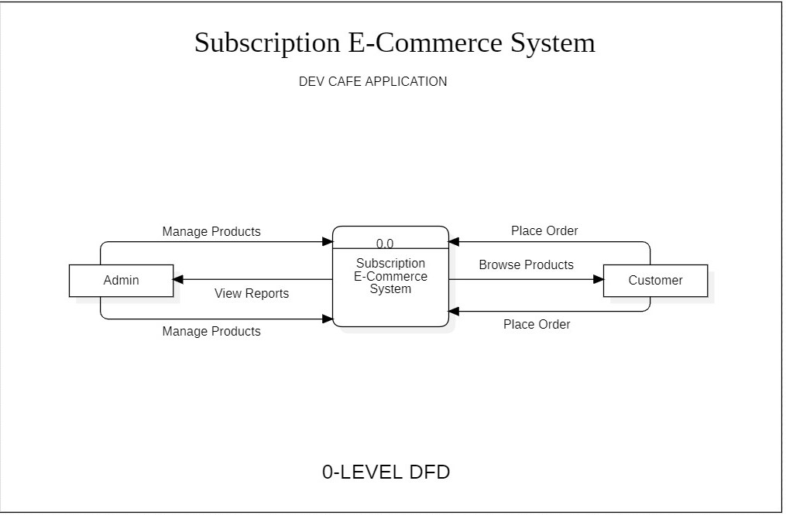

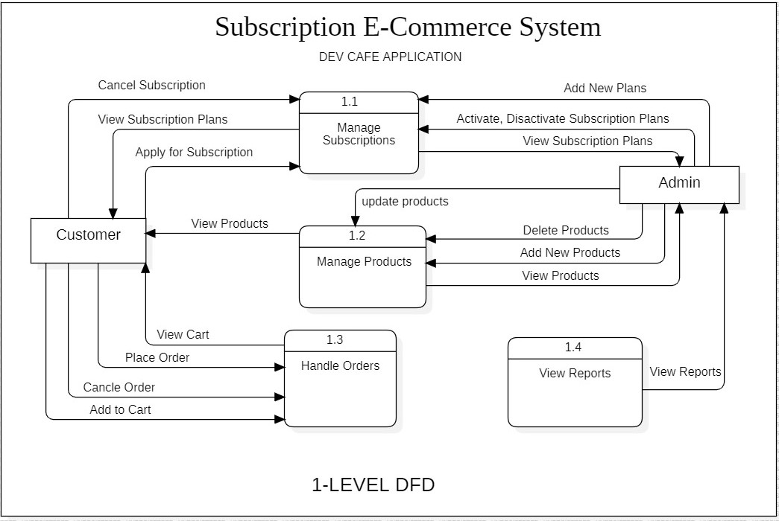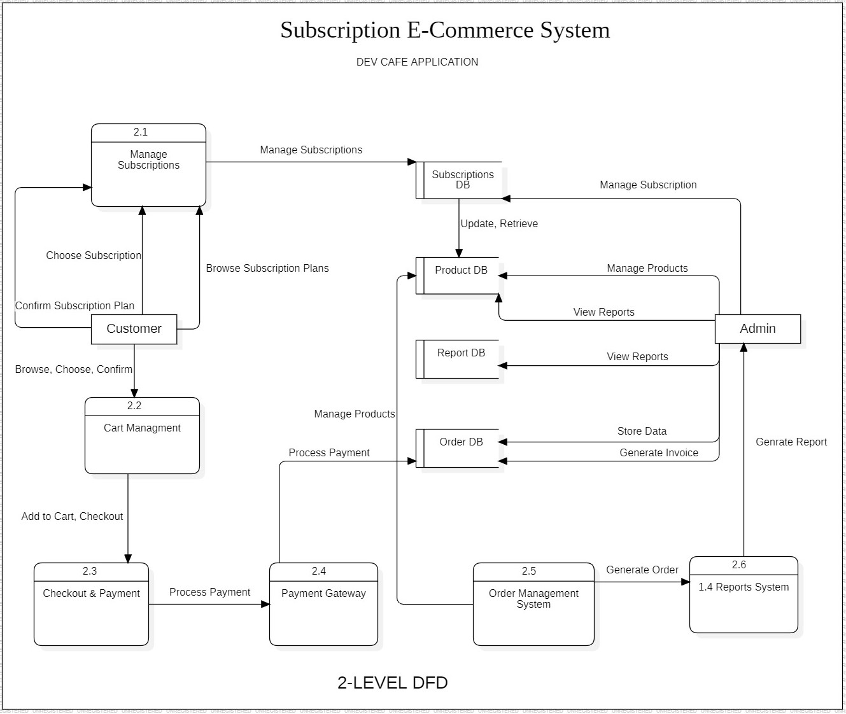

4. Entity-Relationship (ER) Diagram

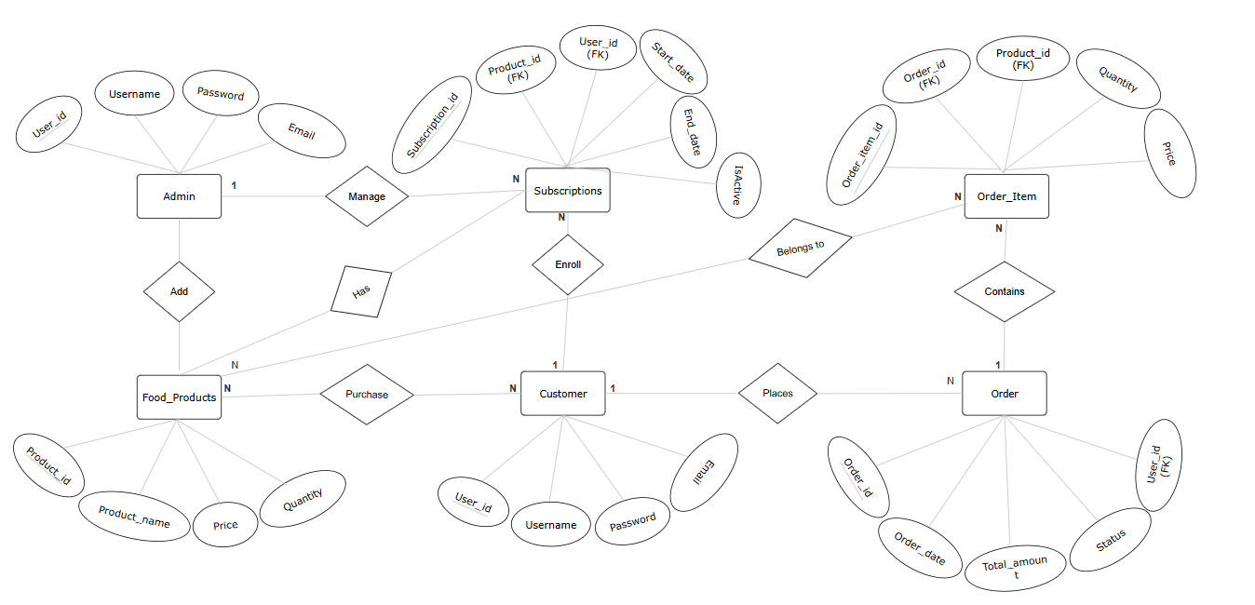

5. Class Diagram (UML)

